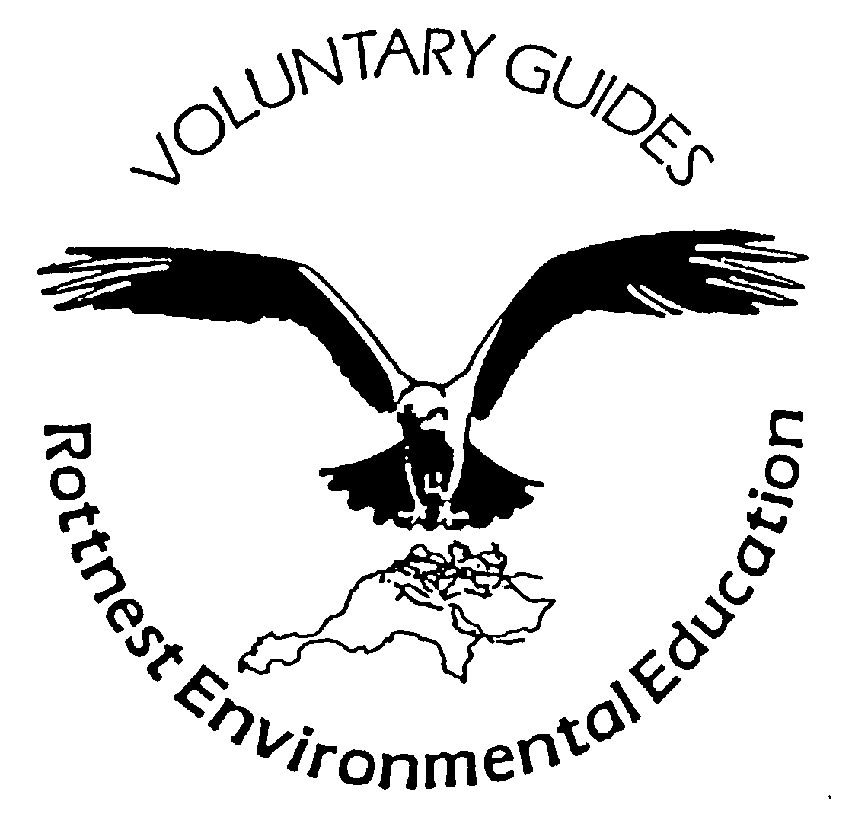
Rottnest Voluntary Guides Association Inc.

New Zealand Fur Seal... on Rottnest Island?
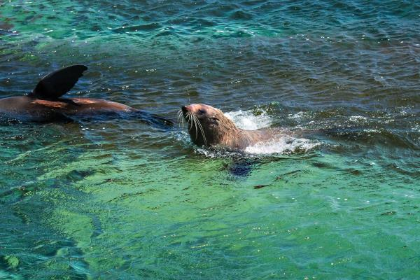
New Zealand Fur Seals mainly breed in New Zealand (as the name suggests), however they are also found around Australia’s southern coasts including here in Western Australia (WA).
WA is very fortunate to have New Zealand fur seals. Fur seal colonies were wiped out from most parts of Western Australia’s southern and western coasts by sealers in the early 1800’s and by the 1850’s had sadly been pushed to the brink of extinction. The destruction to fur seal populations was identified and they became protected under the Marine Mammals Protection Act. Thankfully, these big, but very cute mammals began to reappear off the Leeuwin-Naturaliste coast in small numbers in the mid-1990s and population numbers have been increasing along the west coast ever since.

Rottnest Island is lucky enough to host a colony of New Zealand fur seals at the western end of the Island. Anywhere between 10 and 80 seals can be seen around Cathedral Rocks at any one time. You can often spot them thermo-regulating in the water, which looks a bit like they're doing a spot of yoga or some very flexible ballet poses.

New Zealand fur seals differ in appearance from other seals. They have external ear flaps, a more pointed snout and are darker in colour. They also have hind legs, giving them the ability to move around on land, although they are quite slow and clumsy when out of water. They’re large animals with some of the males, referred to as bulls, weighing up to 180kgs and reaching up to 2.5kg in length. Just to give you some perspective - this is heavier than the average cow!

Fur seals are very agile and fast in water, using this speed and agility to hunt their prey. Their meal of choice consists of squid, octopus and fish; however, on land they have also been spotted eating some seabirds, including penguins! These creatures of leisure prefer to rest during the day and feed at night. Their main predators include sharks, orcas and sea lions, although other threats include climate change and human disturbance such as divers, boat traffic, entanglement in fishing nets, debris and pollution – in particular oil spills.

They are very playful and curious animals and will come right up to you to check you out, however being wild animals, are capable of delivering injury to humans. Some seals can become aggressive and may bite, resulting in an injury similar to that of a dog bite - so it’s best not to get too close.

If you’re interested in seeing New Zealand fur seals playing in their natural environment, you can spot them from the viewing platform at Cathedral Rocks. If you’re a reasonably experienced rider, you can cycle the 22km round trip to the western end of the Island, alternatively for a small fee you can relax in the climate control comfort of the bus service. If you’re aboard a boat, please take note of the safety zones in place at Cathedral Rocks, installed to protect the both fur seals and humans. We encourage you to be mindful in keeping a safe distance when observing these magnificent mammals.

Please remember that Rottnest Island is an A-Class Reserve renowned for its high conservation and community values. All plants and animals on Rottnest Island are protected by law. Wildlife shouldn’t be disturbed and we encourage you to observe from a reasonable distance. Please enjoy these natural wonders during your visit and appreciate the need to conserve this Island paradise for future generations to enjoy!

- The Rottnest Island Team

Source: Rottnest Island Authority's Website

