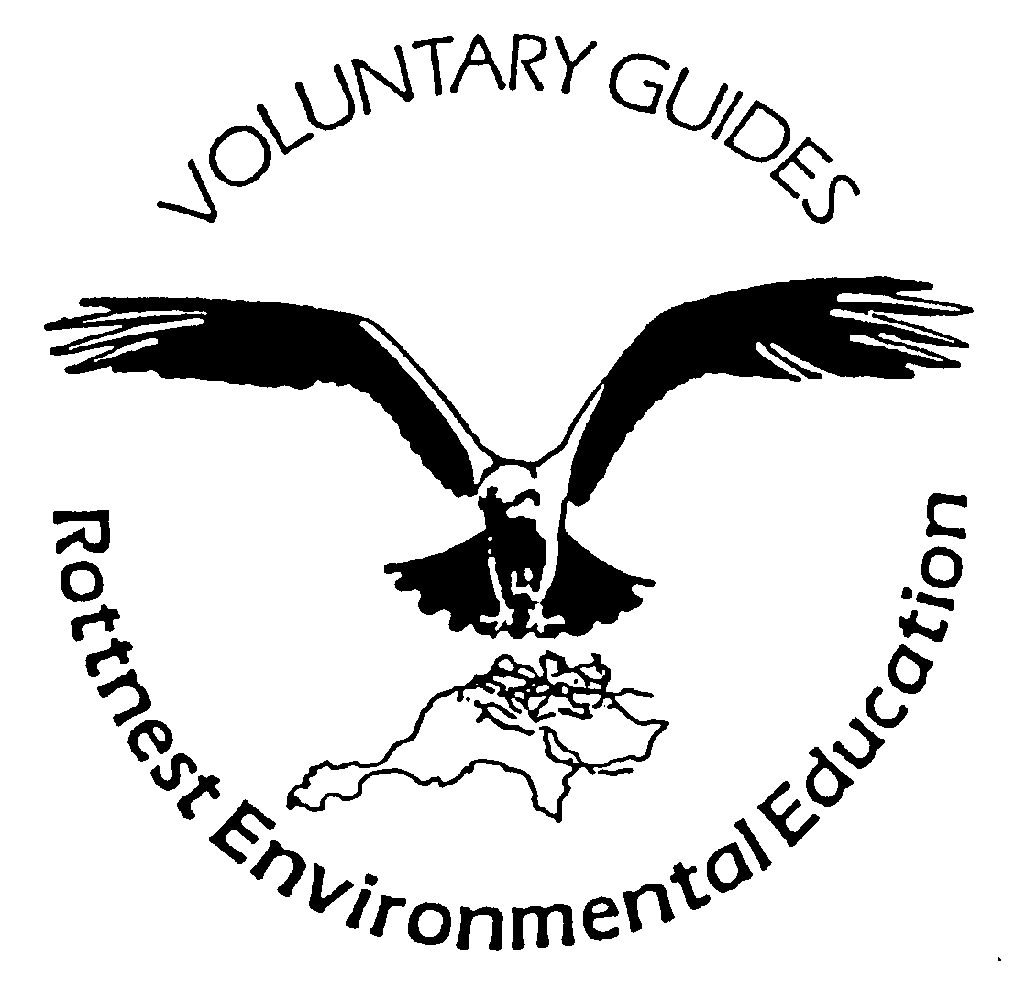
Rottnest Voluntary Guides Association Inc.
Fay Smith, Nursing Sister at Rottnest 1961
Nursing sister, Fay Smith, went to Rottnest Island to the Nursing Post in November 1961 taking her two small children. The first employment was for two weeks in the school holidays. This later became permanent employment. There was some incentive. A three-bedroom house was provided, rent-free and with free electricity and gas.
The original Nursing Post – surgery, waiting room and store – was erected by the Rottnest Island Board from pre-fab materials. The house opposite was equipped by the Winnit Club – a group of volunteers who loved Rottnest. The first two years’ salary was also paid by the Winnit Club. All stores and medical supplies were ordered through the Medical Department and Government Stores. The post was poorly equipped at first – just adequate! It improved gradually. Later, extra rooms were added – a 2 bed ward and kitchen, shower and toilet. Hours were 7 days a week and 365 days a year. Official surgery hours were 10-12 and 2-4pm, but Fay was on call 24 hours a day and did work long hours as it was difficult to get relief staff.
Holidaying doctors – mainly general practitioners – helped enormously. They came to enjoy a holiday and relax with their families. They gave advice on patients and educated on drugs new on the market and their suitability for use. Fay relied heavily also on communication with casualty registrars at the teaching hospitals – Royal Perth Hospital, Sir Charles Gairdner, Fremantle Hospital and Princess Margaret Hospital – who advised Fay according to her reported to signs and symptoms and possible diagnosis.
As Nursing Sister, Fay was responsible for the health of the locals, including injuries to local tradesmen, prenatal care of resident mothers, epidemiology of local children – all booster injections – polio, triple antigen etc – working in conjunction with the Perth based department. Then there were various accidents, fractures, sutures and general health of tourists.
Use was made of the Flying Doctor Service. One occasion recalled was an evening visit to a four-year-old who had had a fall several hours earlier. He presented all signs of internal haemorrhage. Fay suspected rupture of spleen. Thankfully RFDS already had a plane on circuit. The child was in hospital at PMH in 58 minutes. He survived!
Patients were carried on stretchers on ferries and regular aircraft flights were used. On occasion a charter flight would be required with a return trip if Fay had accompanied the patient.
Charges at the Nursing Post were minimal and later became free. Conditions of patients varied considerably – serious to minor – coughs, colds and lacerations, abrasions, embedded fish hooks, intoxication of the “young”. School holidays were very busy! In the varied situations many patients expressed sincere gratitude for the ‘on the spot’ nursing. Also treated on occasion – local horses, cats, birds, quokkas, ducks and one swan!
After a few years, a decision was reached by the Medical Department to upgrade the nursing post to the equivalent of a 5 bed hospital. The salary then became quite respectable – but still no payment for overtime! Prior to this supplement, the wage paid by the Winnit Club, Fay earned extra cash washing dishes at night at the Tea Rooms, and made curtains for the Rottnest Board accommodation.
Fay resigned after ten years to marry Des Sullivan and worked part-time for 4 years.
(Desmond J Sullivan, Managing Secretary, Rottnest Island Board, 1959-1984)

