
Rottnest Voluntary Guides Association Inc.
The Armstrongs – Father and Son

Adam Armstrong (b. 1786) arrived at the Swan River Colony on the "Gilmore" in 1829 (with Thomas Peel) bringing five sons and a daughter (ages 19 yrs to 6 yrs). He had married a Miss Margaret Gow in 1810 but was now widowed. His allocation of land was named Ravenswood after his farm in Scotland. After 18 months, Adam Armstrong broke his contract as accountant and surveyor to Peel and used his contacts to gain a selection on Melville Water where he developed his farm "Dalkeith". This was later sold, part of it going to the Gallop family, and he moved back to Ravenswood.
(It is interesting to note that Adam Armstrong is reported to have lost an eye at Waterloo. Also that his grandson, George, (1860) son of Christopher, married Vincent's granddaughter Louisa, (1863), daughter of Francis Henry, in 1884, in Fremantle.)

Francis Fraser Armstrong (b.1813) the second son of Adam Armstrong, was just 16 years old when he arrived in the colony in 1829. In 1831 he would have come to live at Dalkeith Farm with his family.

The Armstrongs met the prominent Wesleyan, Mr Joseph Hardey, of Tranby Park and Francis became one of his foundation Sunday School teachers, teaching pupils after services under a gum tree in William Street.

He later worked for Mr George Fletcher Moore, a leading colonist, and became fired with evangelical zeal. He had extended his missionary work, organising classes and lessons for Bibbulmun children in Bible study, Christian doctrine, and simple reading and arithmetic. His work included compiling a vocabulary of Bibbulmun words. He was said to have a real affinity with the natives.

At various times he was Chief Advisor of Aboriginal Affairs to Governors Stirling and Hutt and was official Interpreter for Aborigines in the Courts.

In 1834, just 21, he was placed in charge of the newly established Aboriginal Institution at a freshwater spring on the banks of the river below Mt Eliza. It closed in 1838.
In 1835, only six months after the battle of Pinjarra, Armstrong interviewed the survivors and the record of interview is preserved in the State Library.

In 1836 he was instructed by Sir James Stirling to carry out a name census of the Aboriginal population between Yanchep and Mandurah.
In 1836 Francis Armstrong married Mary Ann Mews. Their first son, Francis George, was born in 1837 but died in 1840. Four daughters were born between 1839 and 1845.

He was appointed Constable of Perth soon after the arrival of Governor Hutt in 1839 and was now living in a house in St Georges Terrace.

In 1840 the newly arrived Methodist minister, The Reverend John Smithies, opened the first Aboriginal school in the State and Francis and his wife, Mary, were the teachers. The school closed in 1846.

In 1843 and again in 1846 Armstrong accompanied Charles Symmons, Protector of Natives, to Rottnest to report on prison conditions there, and in 1847 he was sent as moral agent to the Rottnest establishment to instruct the prisoners in Christianity. His second son, Francis Gow, was born there in 1847. Vincent burdened Armstrong with additional duties as storeman and lighthouse keeper.

In 1848 Armstrong fell ill and left Rottnest but he continued his career for many years as teacher, interpreter etc. and, if the records are correct, had ten more children - six sons and four daughters. He died in 1897 and is buried in the East Perth Cemetery. He is honoured by a stained glass window in Wesley Church (1976) and a memorial plaque in St Georges Terrace for 1841 (W.A 150 years in 1979.)
References to the Armstrongs in the history
"Nedlands from Campsite to City" (1984) and Neville Green's "Nyungar" as well as our other Rottnest reference books.

Margaret Findlay 1998

Francis Fraser Armstrong – More information

Francis Fraser Armstrong was 16 when he arrived in the Swan River Colony in 1829 with his brothers and widowed father. He apparently had a natural linguistic ability for he learned the Aboriginal (Nyoongar) dialects in the colony and this led to him being appointed as Government Interpreter. Part of his duties as interpreter included representing and interpreting for Aboriginal prisoners in the Magistrate's Court.

In 1835 he married Mary Ann Mews and together they conducted the Mt Eliza Native Institution, a school for Aboriginals at Goonininup, the site of the old Swan Brewery.

In 1843 and again in 1846 he was sent to Rottnest as part of a commission of enquiry into the treatment of the prisoners. His report concluded that conditions were harsh, but not overly cruel. In 1847, Acting Governor Irwin appointed him to Rottnest as the Morals Agent, with the right to free access to the prisoners and the duty to be present at any punishment. He was to act as storekeeper as well as 'Christianising' the prisoners.

He arrived in 1847 with his wife and five children to live in this house which was only partially completed. Another son, Francis Gow Armstrong was born here in June 1847.

There was some speculation that Armstrong would take over from Vincent, but he was generally regarded as too soft, given his long association with the Nyoongar people.

Apparently there was a good deal of friction between Vincent and Armstrong for Vincent complained to the Colonial Secretary that he wanted a man who could go out with the prisoners and show them how to work, not stop them working, putting them in school and teaching them religion.

Armstrong managed to have Wednesday morning, Friday afternoon and Saturday morning - all rest periods- set aside for his instruction, which began with the story of creation, told in one of the Nyoongar dialects with which he was familiar.

When the pilot boat service was established on Rottnest, Vincent allocated the house to Captain Back - but more of him later.

The promised house for Armstrong did not eventuate and he was forced to live out at the lighthouse and walk in to the settlement every day to carry out his duties. His health suffered and in 1848 he petitioned the Colonial Secretary to be relieved of his duties. He continued to serve the Aboriginal people as Interpreter and is commemorated by a window in Wesley Church in Perth and a plaque in St George's' Tce.
FRANCIS FRASER ARMSTRONG ‐ A GOOD MAN

In the Wesley Uniting Church in Perth, Western Australia, a stained glass window has been erected in honour of this early settler in the Swan River Colony.

This is a short account of a small part of the life of Francis Fraser Armstrong (1813 – 1897).

At the age of 16 years, Francis Fraser Armstrong arrived at the Swan River Colony, Western Australia, on the 15th December 1829, aboard the ship, the “Gilmore”. Francis had travelled from his home town of Dalkeith in Scotland in the company of his father, Captain Adam Armstrong, four brothers and five sisters. (His mother had died prior to this time).

The family settled on land between Perth and Fremantle and named it “Dalkeith”, after their home town in the Midlothian area of Scotland. Francis developed a particular interest in the welfare, customs and dialects of the local indigenous population.

The young Armstrong went to work in the “Fletcher‐ Moore” store and later managed a store for George Shenton in St George’s Terrace, Perth. Francis went on to start his own business as a grain and produce merchant and a commission agent. In 1834, at age 21, Francis was appointed as Government Interpreter and Moral Agent for the Aboriginal people on a salary of ninety pounds ($180) per year.

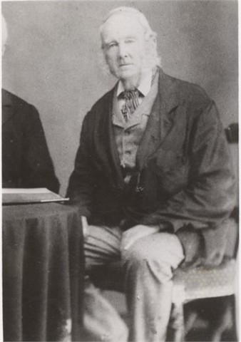
In 1836, at age 23, Francis married Mary Mews and they subsequently had four sons and five daughters. Both Francis and Mary continued their mission with the interests of the Aboriginal population of the settlement. Francis went on to co‐write two books of translation from Aboriginal dialects to English, a first for Western Australia. Francis continued his association with the Wesleyan Methodist Society and the Tranby Methodists. (Mary had been raised as an Anglican.)

In 1847, Francis was appointed, by the Governor, as the Moral Agent to the Aboriginal prisoners, accountant and storekeeper on Rottnest Island. His mission was to educate and bring religion to the prisoners and to tend to their welfare. He was not welcomed to the Island by Henry Vincent, to say the least, and their relationship remained strained for the duration of his relatively short tenure on Rottnest. Francis sat on two tribunals, in which the welfare of the prisoners was the major concern and Henry Vincent was called to account for the treatment of the prisoners in his charge.

Francis had to complete the building of his cottage for his family, (now known as K1 and K2). In 1848, the Armstrong family were forced to move to a partially constructed cottage near Wadjemup Lighthouse. This was to enable Captain Edward Back, the first Captain of the Rottnest Pilot Boat Service, his family and crew to move into the former Armstrong family residence.

Eight months later, purportedly due to increasing ill health, Francis Armstrong relinquished his position and returned to the mainland with his family. Because of his affiliation with the Aboriginal people and work with the Church, Governor Hutt granted seventy pounds ($140) per year to establish and run an Aboriginal mission in the Mount Eliza Bay area (below Kings Park).It was from here that Francis and Mary ran the first school for Aborigines in Western Australia. This mission was deemed to have been a successful enterprise.
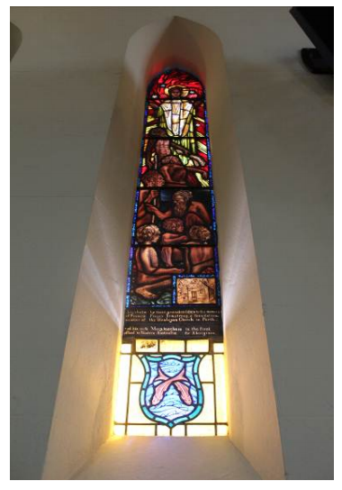
Francis Fraser Armstrong continued his altruistic work until his death on 22nd May 1897 at the age of 84, his wife, Mary, having pre‐deceased him by several years.

The images on the stained glass window depict Aboriginal youths being taught by Tribal Elders. The inset in the right hand corner is a representation of the first Methodist Church in The Swan Colony.

The inscription reads: “A tribute by their grand‐ children to the memory of Francis Fraser Armstrong, a foundation member of the Wesleyan Church in Perth, and his wife Mary, teachers in the first school in Western Australia for Aborigines.”

Wayne Endersbee (Francis Fraser Armstrong is the Great, Great Grandfather of Wayne’s wife Joanie)

